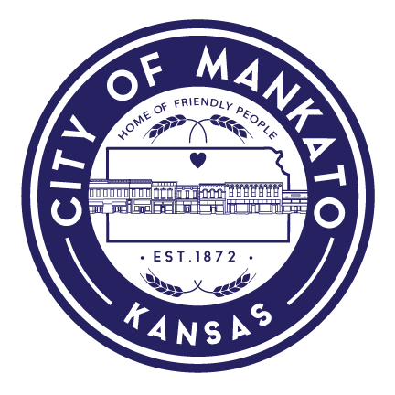
City of Mankato
217 S. High Street
785-534-7512

7/26/2021

Citizens of Mankato,

The city has switched over to the new billing software and staff have worked hard to work out the kinks with the ACH files. We will have hiccups along the way; however, the new billing system will give each customer more options to pay their utility bill. If you are an ACH customer, we will start your ACH accounts on or about August 10th, 2021. If you do not want automatic withdrawals to continue, please call the city and opt out. If we do not hear from you, we will reinstate previous ACH accounts.

We are currently working with our accounting program provider to give customers the option to pay their bills online. In addition, customers will have the option to pay with a debit or credit card. We expect this to roll out by the end of August 2021.

If you have any questions, please contact us at 785-378-3141. Thank you.

Barry K. Parsons
City Administrator

